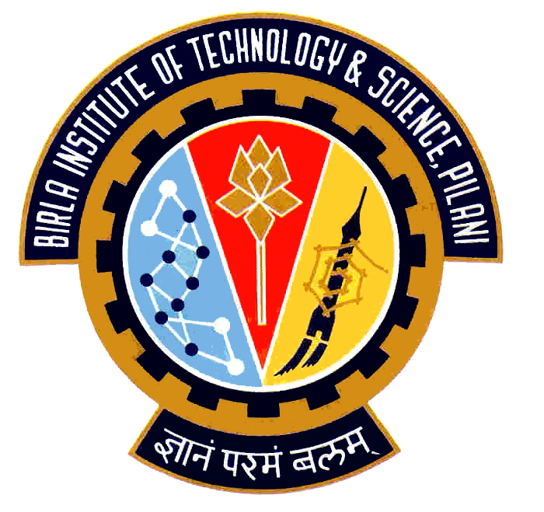

Election Commission

Birla Institute of Technology & Science – Pilani, Goa Campus, Zuarinagar, Goa-403726, INDIA
Tel: (0)98233 6368 Fax:0832-2557033

AUDI DEBATE II

The second debate in the auditorium for the candidates standing for the Executive Committee of the CSA in Elections 2008 will be held on 2nd September, 2008 at 6:00 p.m.

The rules are as follows:

- In the first round, the Presidential candidates are given 3 minutes and all the others 2 minutes each, to present their views.
- In the second round, 1 minute will be given to each candidate to answer the questions posed to him in the first round.
- The third round consists of Audience questions.

In all the rounds, decorum should be maintained both by the candidates and the audience.
In case of any violation of the rules, the decision of the Election Commission and the Chief Warden will be final and binding.

This is your only chance to get the facts from your candidates…..

Chief Warden CEC

